Visualization of raw data
Opening the Weka Graphical User Interface


We are given two Arff files and one CSV, for now lets look at each.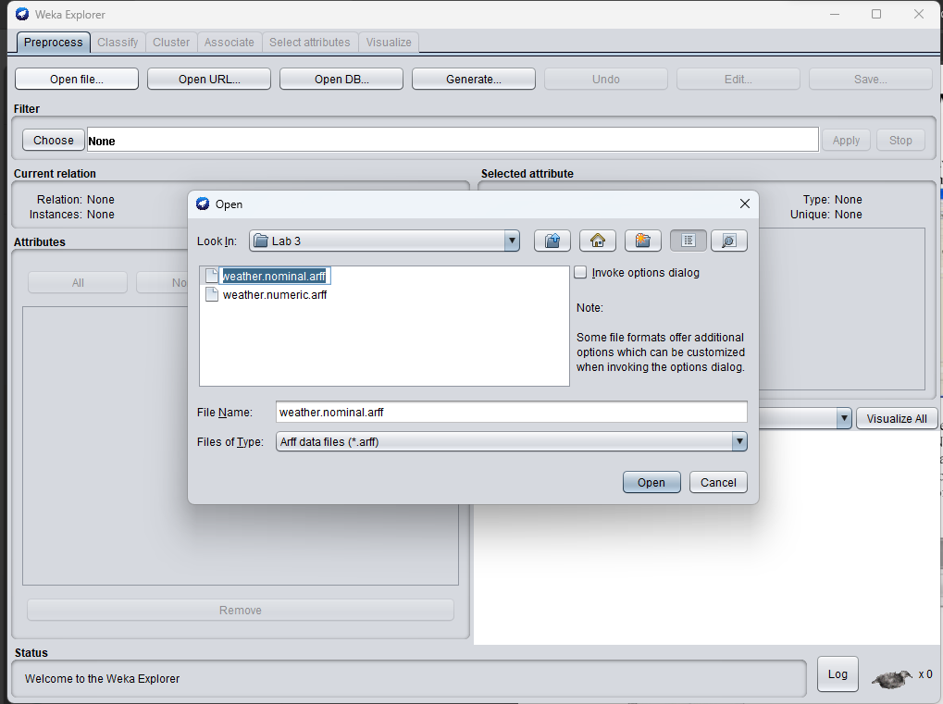
Pressing edit shows us the raw data for us to look in excel/tabular format, we can add instances also.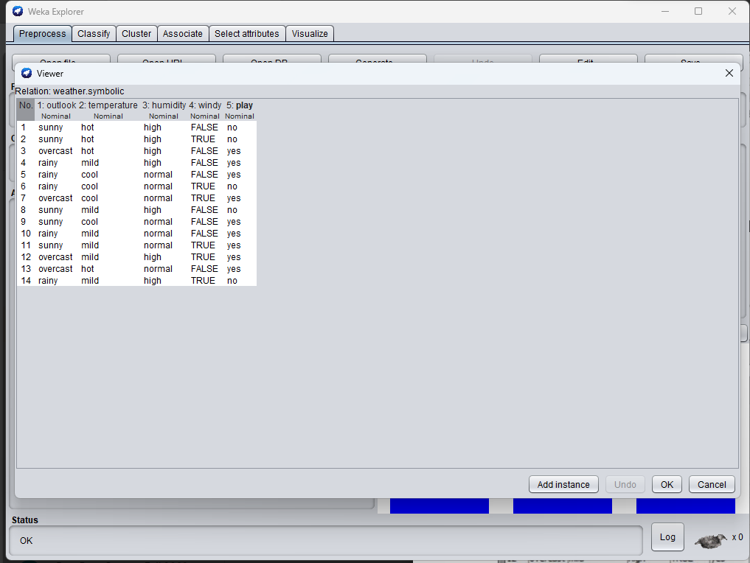

We are in the preprocess tab and can see visualizations based on other attributes and after selecting the attribute we can see the counts of the category and the weights along with other characteristics of categorical data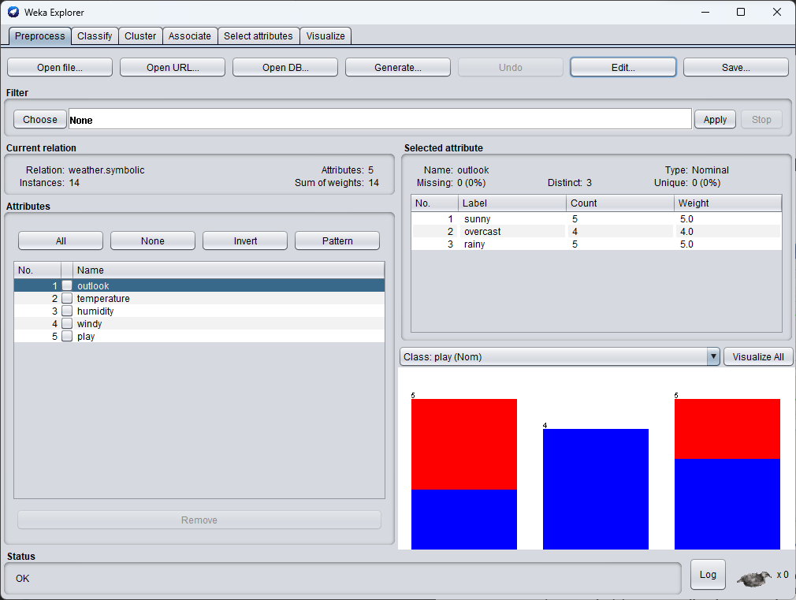

We are now opening the numeric file.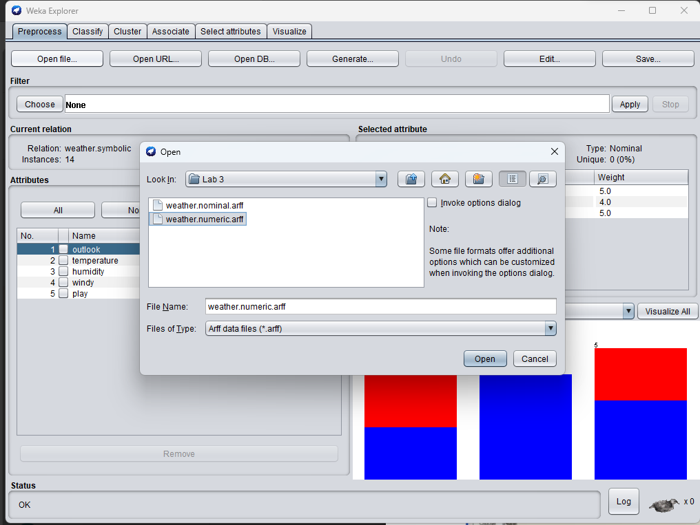

When we select a numeric attribute, the data will have its plot against the selected class as well in the corner, here we can see a right skew showing that play is favoured at 83 temperature, in selected attribute we can see the statistics of the selected column as well as missing values etc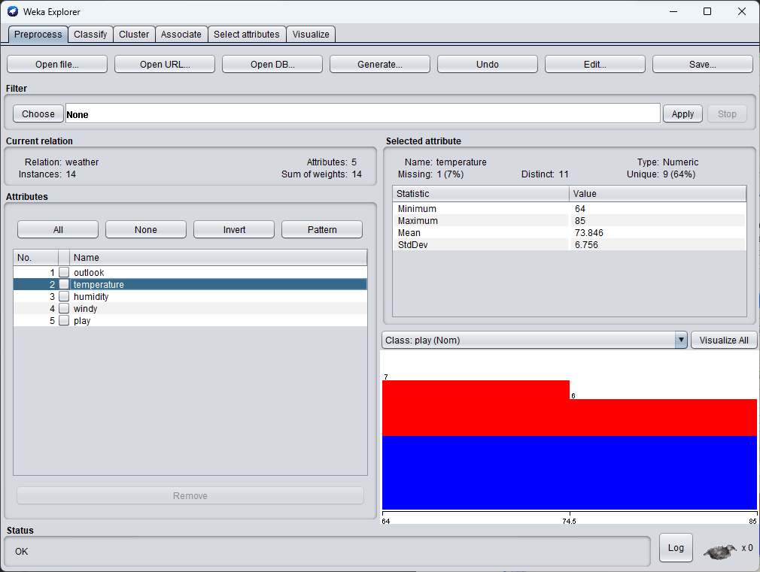
Opening visualize panel we can see a matrix plot better known as pairplot in seaborn, plotsize, pointsize can also be updated realtime, legends are identified in bottom panel.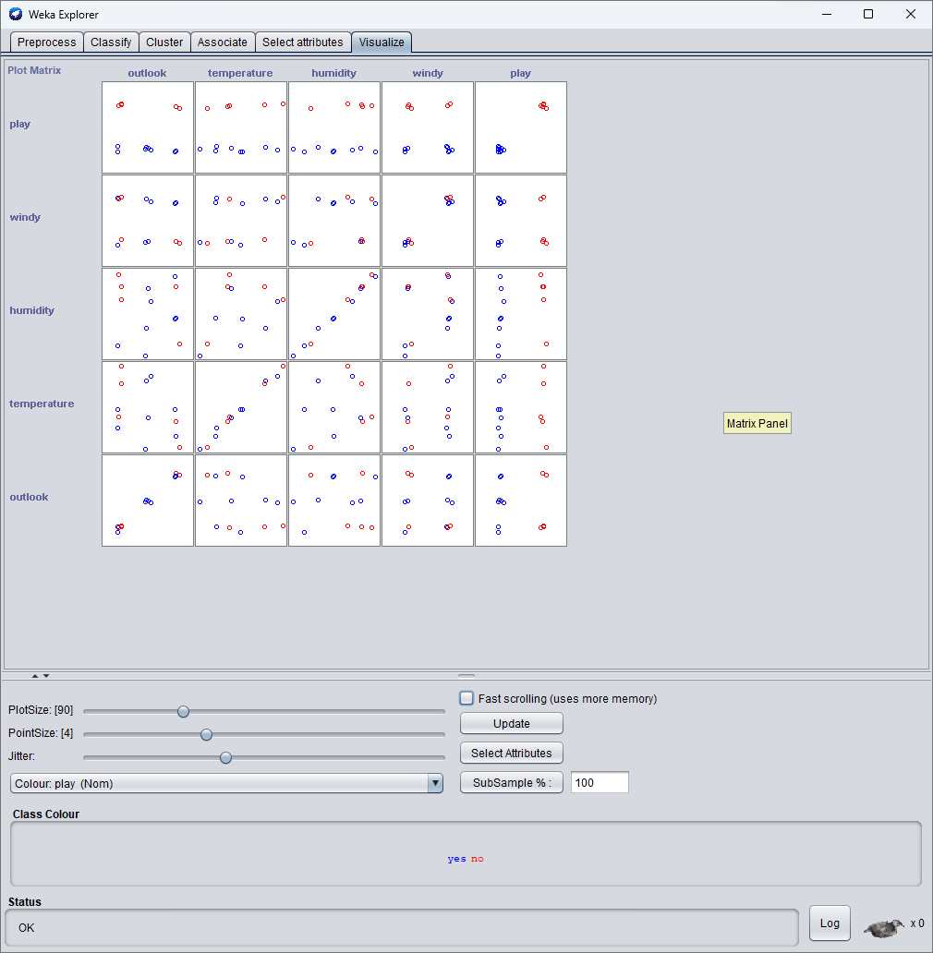

Using Filters to Remove Attributes
We have selected the filter Remove, it can remove data based on indices provided, for that we head over to filter properties. 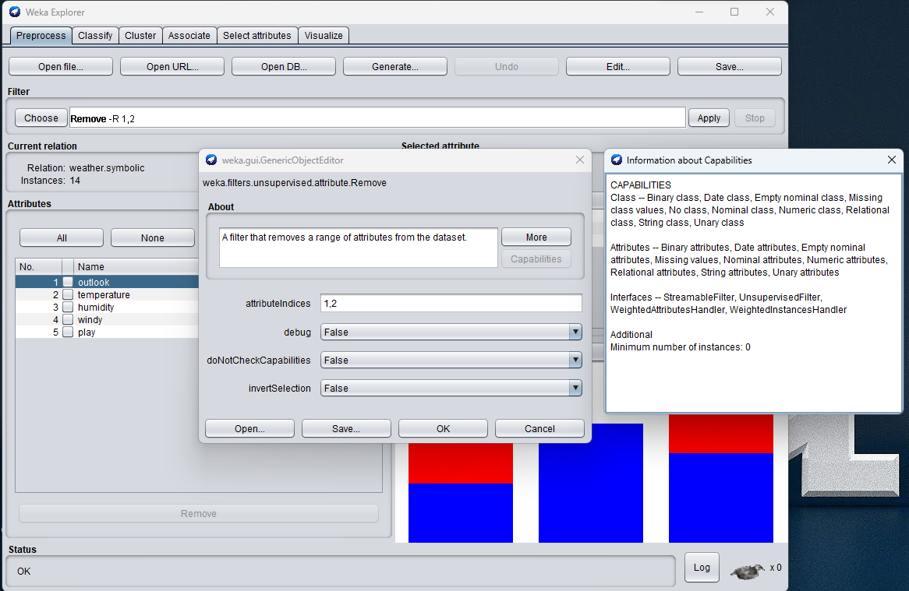Here are attributes before the filter: 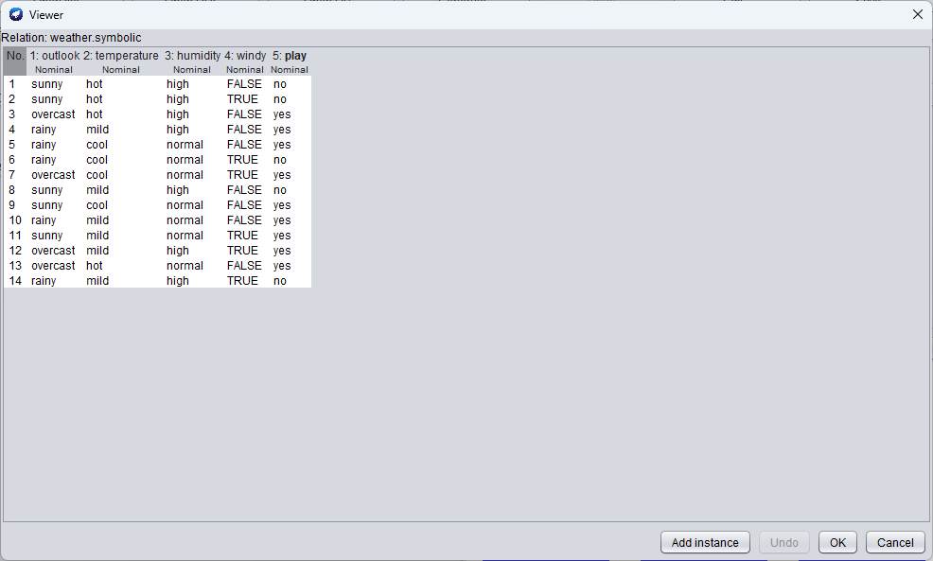
Then after filter: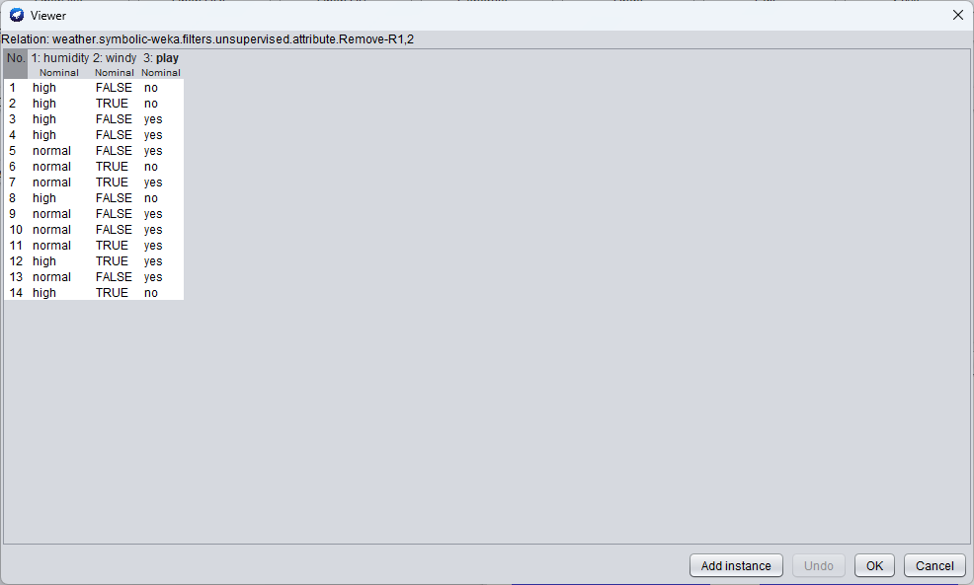
We can then save the processed data as required.
Handling missing data
Using ReplaceMissingValues
Weather.numeric had missing values, lets apply a filter ReplaceMissingValues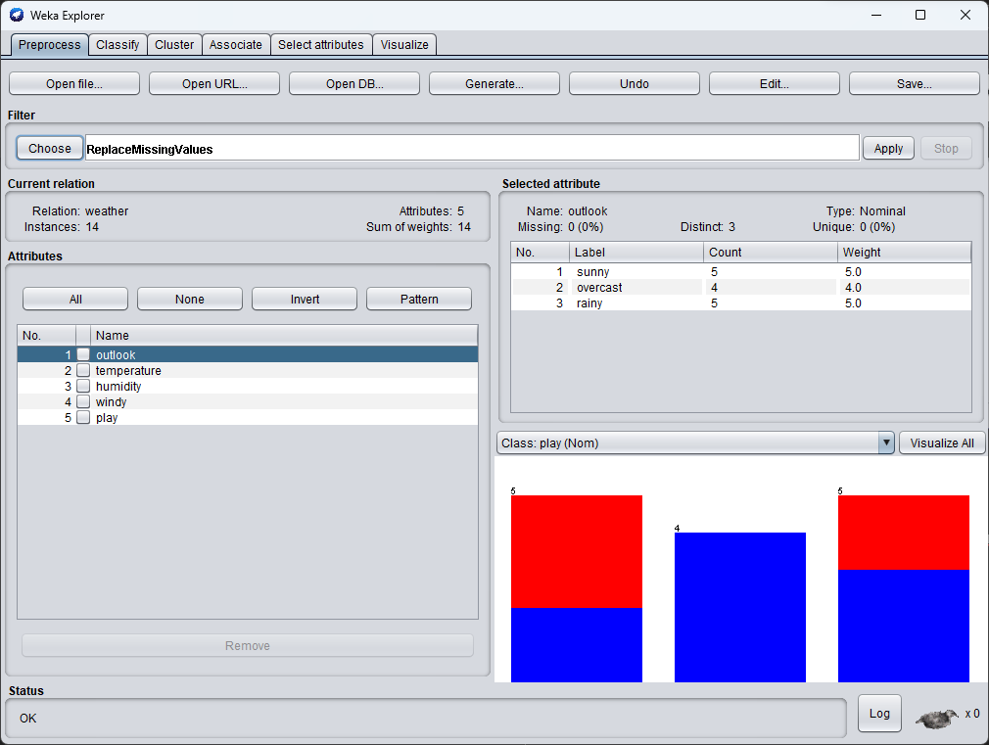
Data before filter: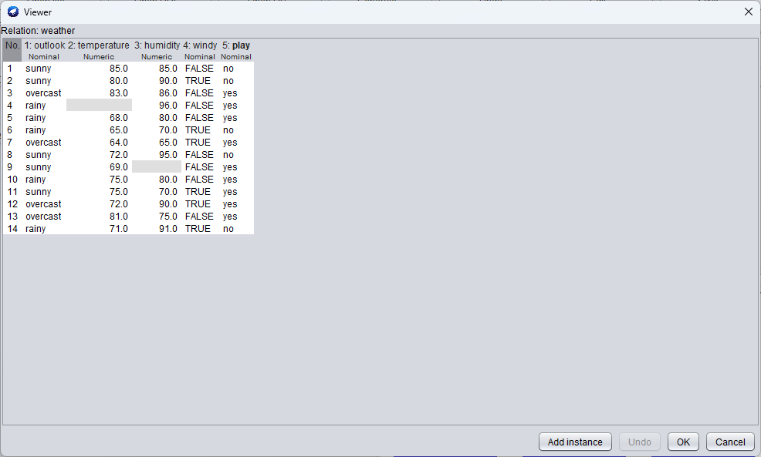
Data after filter: 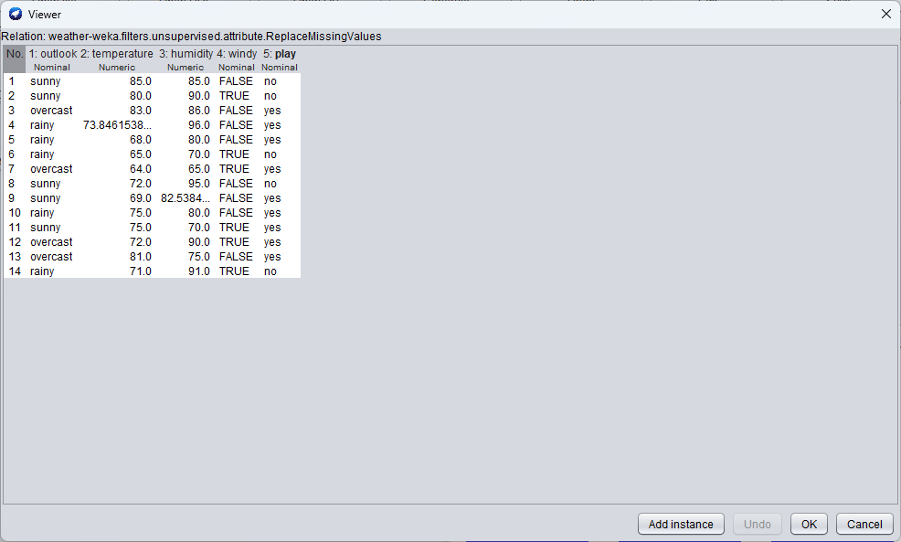
Missing data has been successfully handled.

Using Filters to handle outliers and extreme values
Using InterquartileRange
We will be using small_telco_labOne.csv
Missing data can be seen, lets use ReplaceMissingValues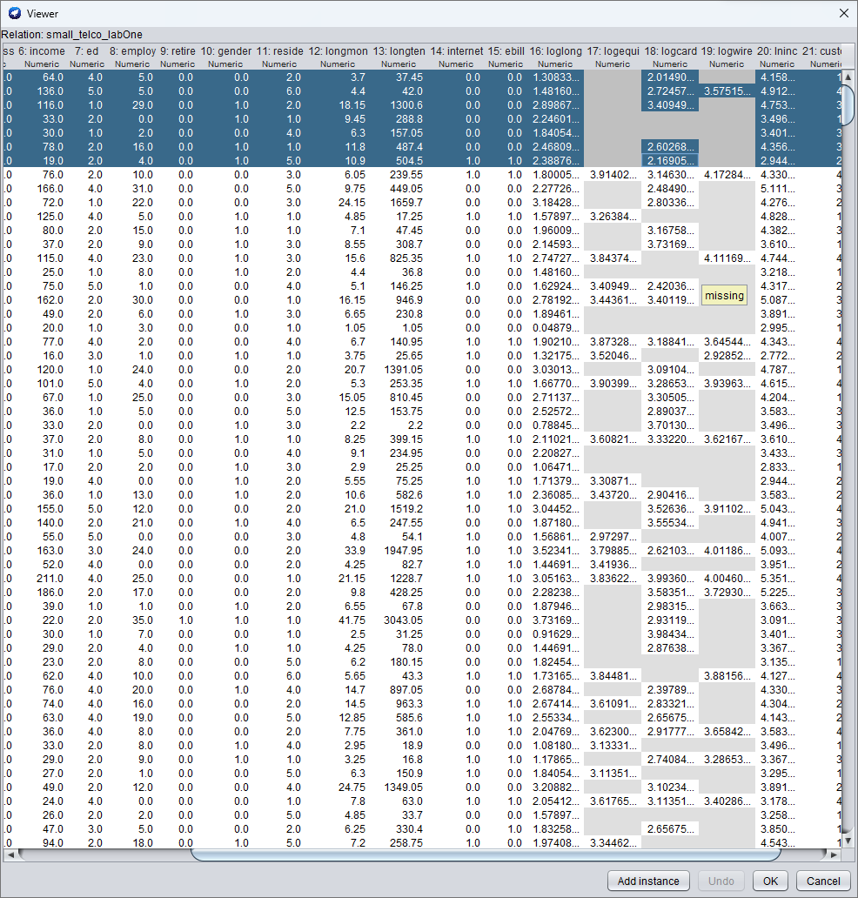
Missing values have been handled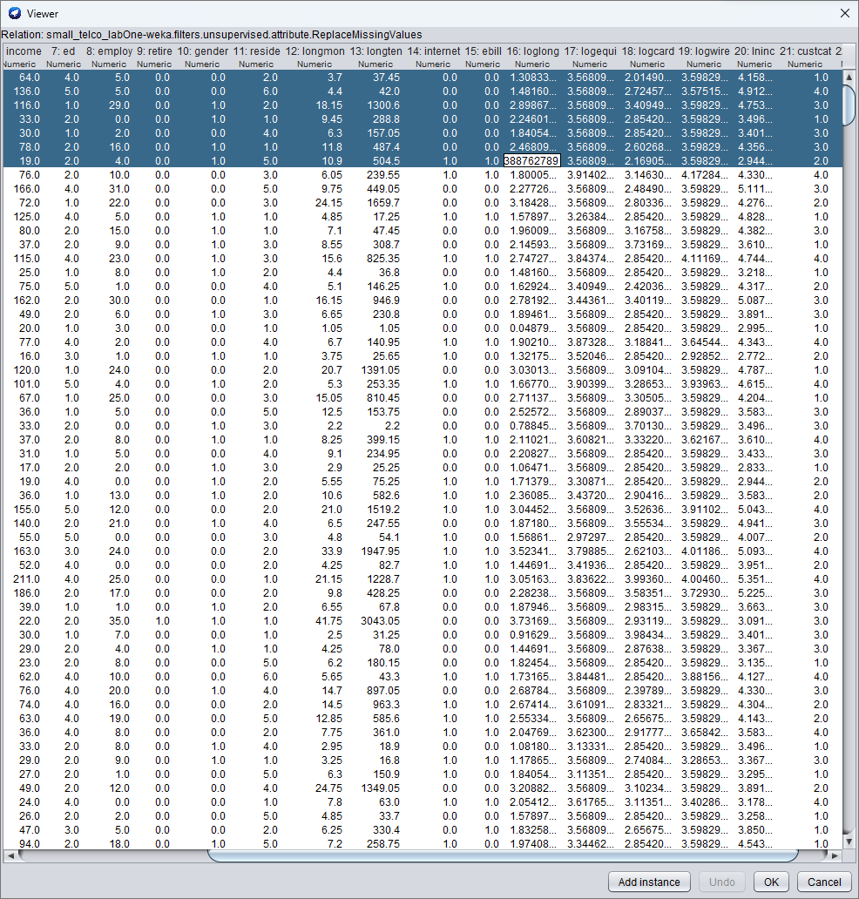
Applying the filter InterQuartileRange as is gives us two extra attributes Outlier and ExtremeValue it skips class and gets outliers and extreme values of each row. 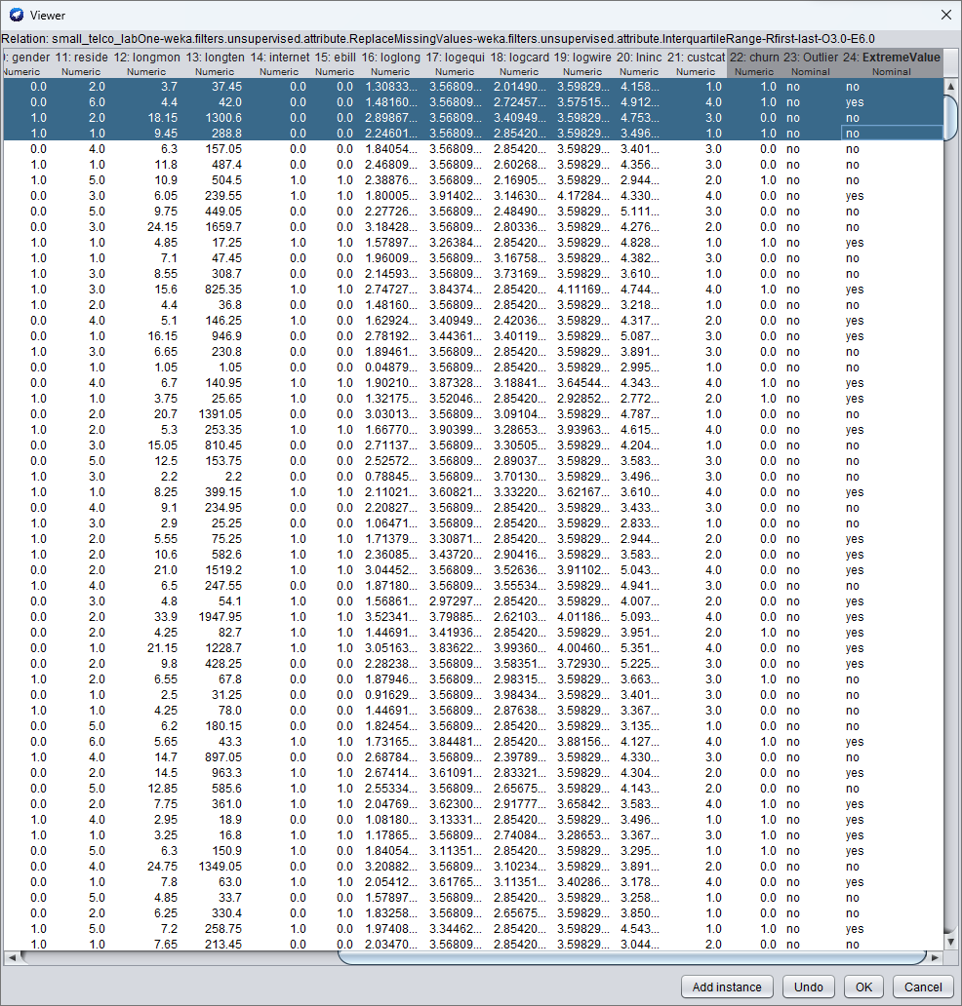
Using attributeDetection we get extra pair of attributes with each outliers and extremevalues
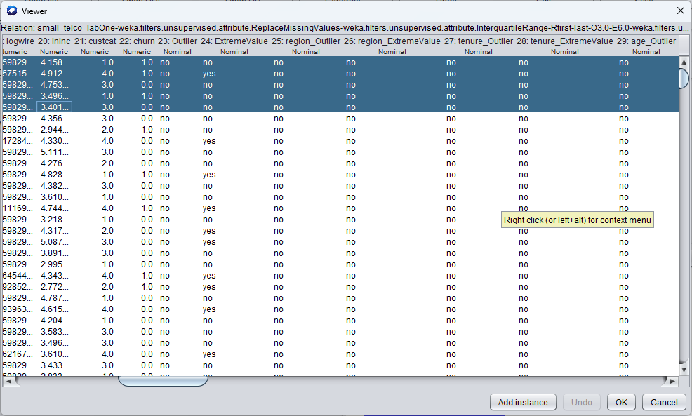
Removing new attributes without any outliers or extremevalues
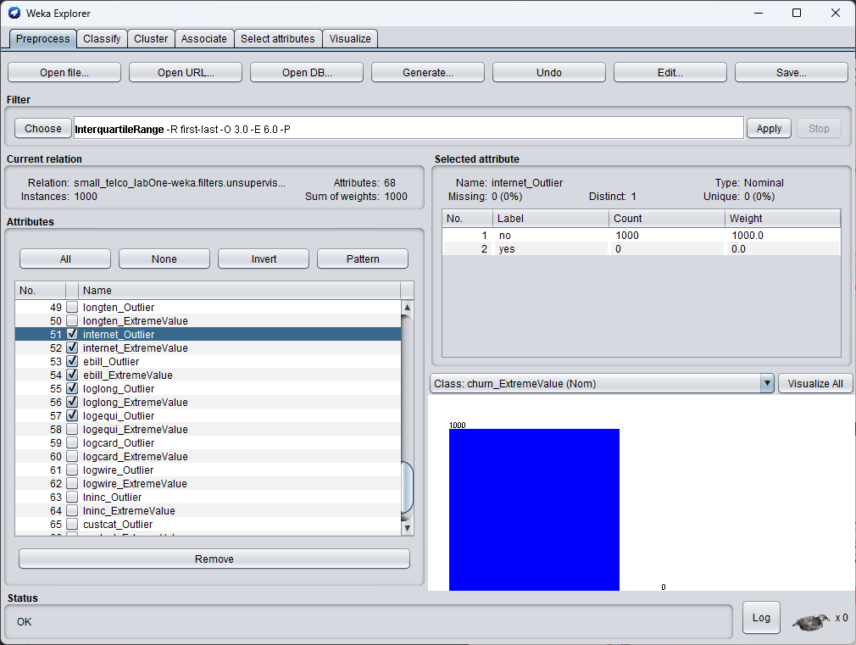
Unsupervised Instance Filter – RemoveWithValues
We can remove outliers completely by going to the attributeIndex (attributeNo 23) and using the last normalIndice (first-no; last-yes) 70 instances are removed and we now have 930 attributes from 1000
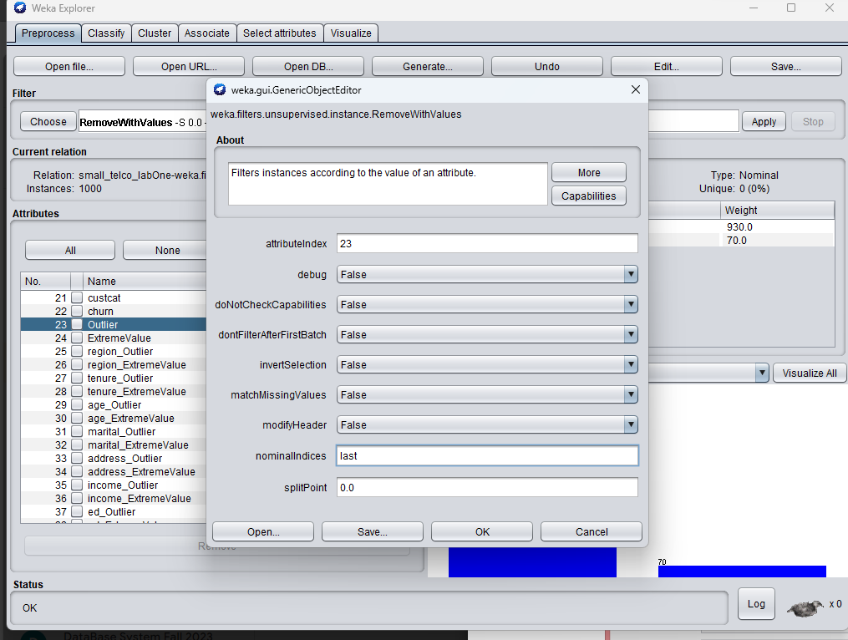
Using filters to perform normalization
Using Normalization of scale 1 [0-1]
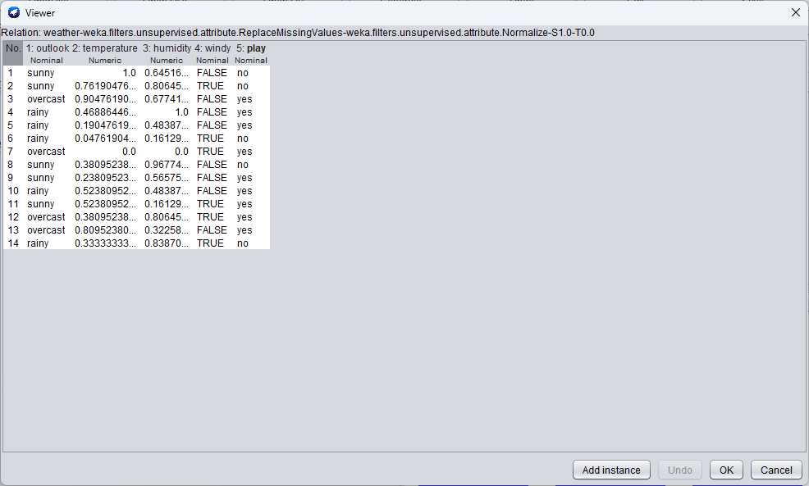
Using Normalization of scale 2 [0-2]
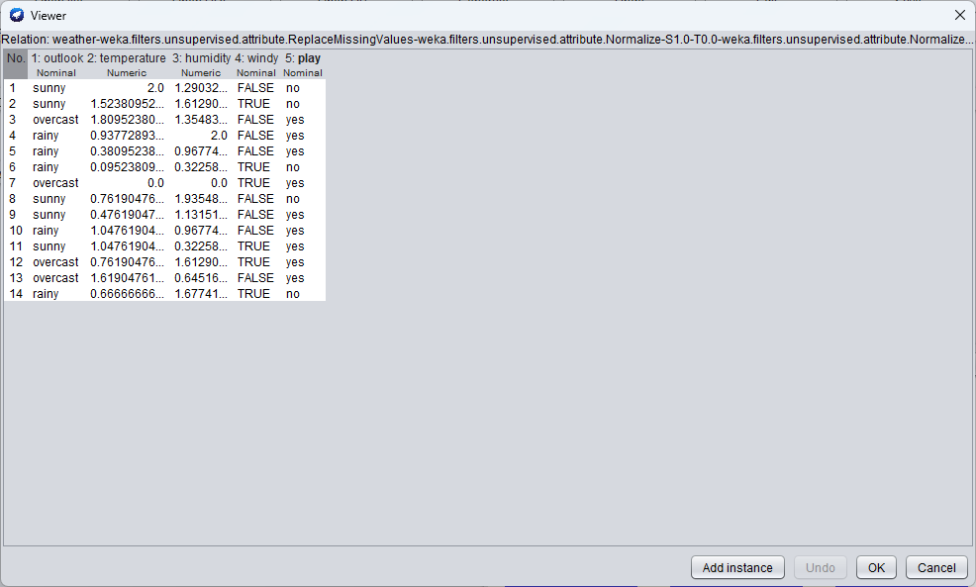
And when we move translation to -1, we will start from -1 and move 2 integers [-1 – 1]
